Use-Case Realization Report
Authentication

Issue <1.0>
Revision History
Date | Issue | Description | Author
09 May 2011 | 1.0 | First Issue | Junaith

Table of Contents
1. Brief Description 4
2. Flow of Events 4
3. Interaction Diagrams 4
3.1 Collaboration Diagram for Authentication 4
4. Participating Objects 4
4.1 Employee 5

4.2 Login 5

4.3 Logout 5

4.4 FormLogin 5
5. Class Diagrams 5
6. Derived Requirements 5

Use-Case Realization Report
Authentication

Brief Description
The use case enables the Employees to Log In and Log out of the COMS System as well as provides them with access rights to different parts of the system based on their authorization.

Flow of Events
The standard flow of events for this use case and any exception are described in the following subsections. The events are described in terms of Actors and Analysis Objects.

Standard Flow
This use case provides the user interface related functionality that will be provided to the Employees, as follows:

Log-In
To commence using the system, the Employees are required to log-in as follows:
- The Employee is required to enter a valid password into the Home Page.
- The system will check that the entered password is valid.
- If the password is invalid then the caption “Invalid Password” will be highlighted on the Home Page.
- If the password is valid (ie: the Employee has successfully logged-in), then the following will occur:
- The welcome message will be displayed.
- The Employee will be given access to the required functionality according to the authorization.

User Functions
If the Employee logs-in successfully, then the following functions are available to the employee
- The Employee will be transferred to the relevant pages according to their authorization:
- Each staff can do their relevant transactions now.

Log-Out
- The Employee will terminate use of their relevant function (ie: log-out) by pressing a button with the caption “Log Out”. A Message box will pop out to ensure if the Employee would like to Log Out if ‘Yes’ is clicked, then the log-out request will be successful.
- If the log-out request is successful then the following will occur:
- The login button will be enabled.
- The Employee will be transferred to the Home Page.
- No transaction can be carried out until Logged in.

  - Exception
The following exceptions have been identified:
- Login fails, if the Employee is not authorized.
- Unable to perform the necessary transaction if connection is lost.
- Unable to connect to system if system is down.

Interaction Diagrams

Collaboration Diagram for Authentication

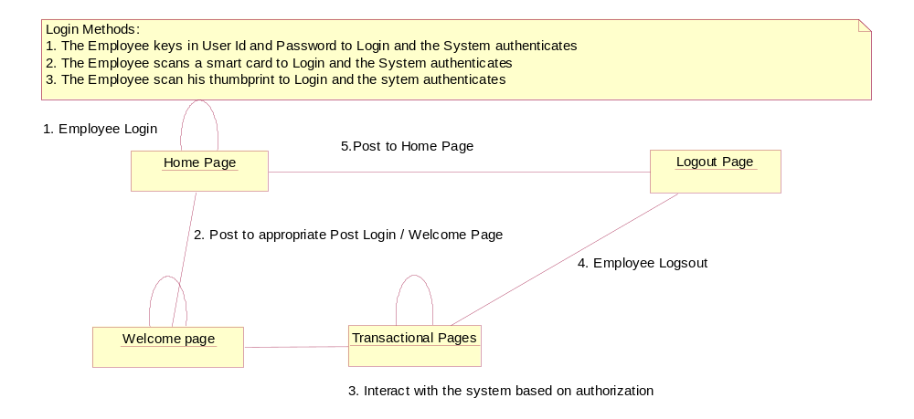

Participating Objects
: Employee
The Employee actors logs in and logs out of the system as well as interact with the system according to their authorization.
: Login
This function authenticates and authorizes each employee to access and use the system’s functionalities.
: Log out
This function let the employee logs out of the system.

: Form Login
This Form lets the Sales Staff actor to:
- Login to the system.

Class Diagrams

Derived Requirements
A computer capable of running .Net and SQL Server programs is required to run this software.
A smart card reader if the authentication is to be done using Smart card.
A bio metric device if bio metric authentication is needed.
A PC with key board, mouse and display.

